Project Design Phase
Problem – Solution Fit Template

Date | 14 Feb 2026
Team ID | LTVIP2026TMIDS88463
Project Name | FreelanceFinder – Discovering Opportunities, Unlocking Potential
Maximum Marks | 2 Marks

Problem – Solution Fit Template
The Problem–Solution Fit involves identifying real challenges faced by clients and freelancers in online freelancing platforms and developing a solution that effectively addresses those issues. It ensures that FreelanceFinder aligns with user needs, improves collaboration, and builds trust within the freelancing ecosystem.

Purpose:
❑ Solve real-world freelancing challenges by providing a secure, structured, and user-friendly platform tailored to Clients, Freelancers, and Administrators.
❑ Increase platform adoption by aligning the solution with existing user behaviors such as remote work, project outsourcing, proposal bidding, and digital collaboration.
❑ Improve communication and transparency by delivering real-time chat, clear project workflows, secure authentication, and structured proposal management.
❑ Enhance user trust and platform reliability by solving common problems such as insecure access, unclear project status, lack of transparency in selection, and poor communication.
❑ Identify limitations in existing freelancing systems and continuously improve the platform to better support secure collaboration, efficient project tracking, and professional growth.

Template:
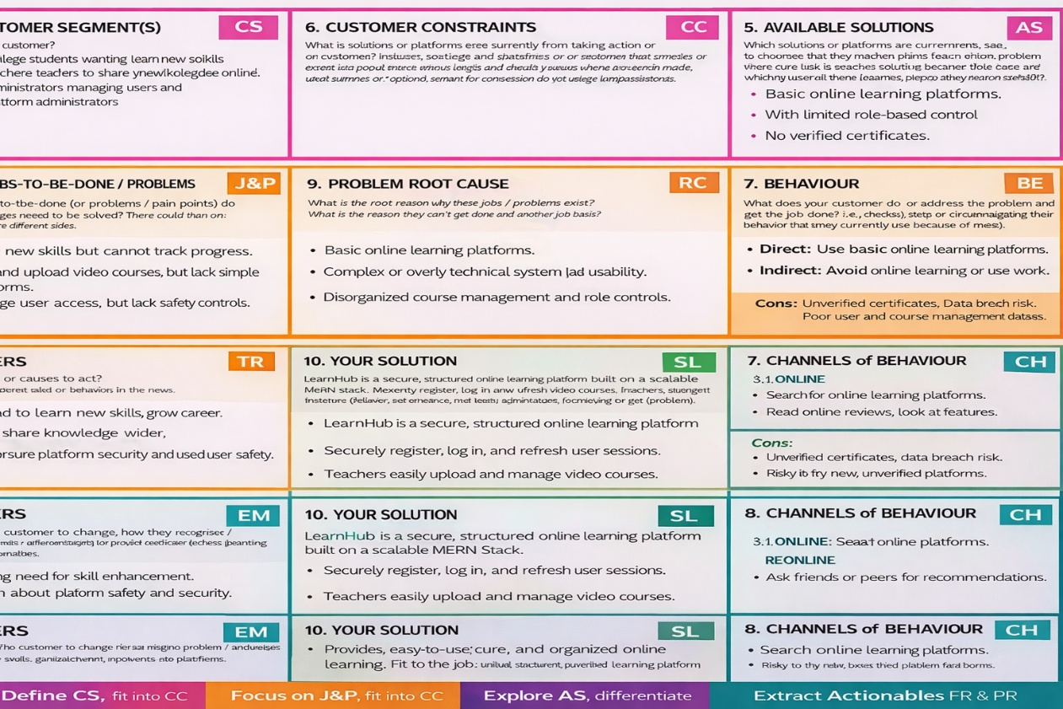

Problem–Solution Fit Template
1. CUSTOMER SEGMENT(S)
• Clients seeking skilled professionals to complete projects efficiently
• Freelancers looking for genuine project opportunities and career growth
• Administrators managing platform integrity and user activities
• Startups and small businesses looking for cost-effective outsourcing solutions

2. JOBS-TO-BE-DONE / PROBLEMS
• Post and manage projects securely
• Find reliable freelancers with relevant skills
• Submit competitive proposals and track application status
• Communicate effectively during project execution
• Prevent unauthorized access and protect sensitive data
• Ensure role-based access and proper system control

3. TRIGGERS
• Growth of remote work and freelancing economy
• Increasing demand for project-based outsourcing
• Need for flexible and skill-based work opportunities
• Businesses seeking cost-efficient hiring solutions

4. EMOTIONS: BEFORE / AFTER
Before:
Confused project management, lack of trust, insecure communication, unclear workflow, difficulty finding genuine opportunities.
After:
Confident collaboration, structured workflow, secure communication, transparent selection process, improved professional growth.

5. AVAILABLE SOLUTIONS
• Generic freelancing marketplaces
• Social media-based hiring
• Informal freelance communication platforms
CONS:
• High competition without proper filtering
• Lack of structured project tracking
• Limited real-time collaboration
• Security and data privacy concerns
• Poor admin monitoring

6. CUSTOMER CONSTRAINTS
• Limited budget for premium freelancing platforms
• Lack of technical expertise
• Concerns about secure communication and data privacy
• Hesitation to trust new digital platforms

7. BEHAVIOUR
Direct:
• Register and log in
• Post or browse projects
• Submit proposals
• Communicate via chat
• Submit completed work
Indirect:
• Share portfolio and project success
• Recommend platform to peers
• Build professional reputation

8. CHANNELS of BEHAVIOUR
8.1 ONLINE
• Web browser access
• Dashboard management
• Real-time chat interface
• Project listing and proposal submission
8.2 OFFLINE
• Word-of-mouth referrals
• Professional networking events
• Institutional or startup adoption

9. PROBLEM ROOT CAUSE
Freelancing platforms often lack proper integration between secure authentication, structured project management, proposal tracking, real-time communication, and administrative monitoring. The root cause is the absence of a unified, secure, and scalable full-stack system that ensures transparency and efficient collaboration.

10. YOUR SOLUTION
FreelanceFinder – A MERN-based Freelancing Platform that:
• Implements secure JWT authentication with Bcrypt password encryption
• Provides role-based access control (Client, Freelancer, Admin)
• Supports structured project posting and proposal management
• Enables real-time communication using Socket.io
• Tracks project status and submission workflow
• Ensures admin monitoring and platform integrity
• Offers scalable and modular architecture for future enhancements

